***Compton Effect***

When an energetic photon strikes an electron (*assumed to be initially at rest*), it is scattered away from its original direction of motion while the electron receives an impulse and begins to move. In the collision, the photon may be regarded as having lost an amount of energy that is the same as the kinetic energy gained by the electron. Consequently, *the scattered photon has less energy than the incident photon. Therefore, the frequency of the scattered photon is shorter than that of incident photon. This alteration in frequency or wavelength of the photon due to the collision with electron is called Compton Effect.*

***Compton Equation***

Let an energetic (X-ray) photon of energy $E=hν$ and momentum *hν/c* strikes a free electron at rest. The energy of incident photon will be divided into energy of scattered photon = *hν/* and energy of electron = *K.E*.

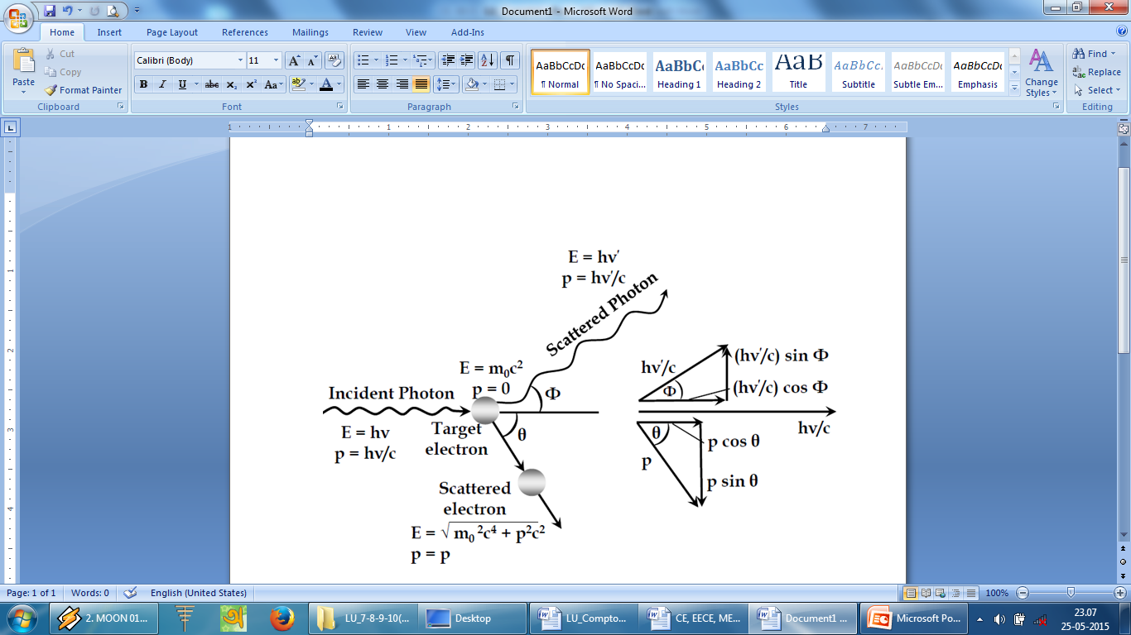

**Fig. 1. Compton Effect.**

For the conservation of energy, we can write

$$Loss in photon energy = Gain in electron energy$$

$$hν-hν^{/}= KE (1)$$

We know the momentum of a massless particle is related to its energy by

$$E= pc (2)$$

Since the energy of a photon is *hν,* its momentum is

$$p= \frac{E}{c}$$

$$p= \frac{hν}{c} (3)$$

Momentum is a vector quantity that incorporates direction as well as magnitude and in a collision momentum must be conserved in each of two mutually perpendicular directions. The directions we choose here are that of the original photon and one perpendicular to it in the plane containing the electron and the scattered photon (fig.1.).

The initial photon momentum is *hν/c* and the scattered photon momentum is *hν//c*, and the initial and final electron momenta are respectively *0* and *p*.

In the original photon direction

$$Inital momentum = Final momentum$$

$$\frac{hν}{c}+0= \frac{hν^{/}}{c} \cos{φ}+ p \cos{θ} (4)$$

and perpendicular to this direction

$$Inital momentum = Final momentum$$

$$0+0= \frac{hν^{/}}{c} \sin{φ}-p \sin{θ} (5)$$

The angle *θ* is that between the directions of the initial and scattered photons and, *ϕ* is that between the directions of initial photon and recoil electron.

Multiplying equations (4) and (5) by *c* we can write

$$pc\cos{θ}= hν- hν^{/}\cos{φ} (6)$$

$$pc\sin{θ} = hν^{/}\sin{φ} (7)$$

Squaring equations (6) and (7) and adding, we get

$$p^{2}c^{2}={\left(hν\right)}^{2}-2\left(hν\right)\left(hν^{/}\right)\cos{φ}+{\left(hν^{/}\right)}^{2} (8)$$

We know the total energy

$$E= KE+m_{0}c^{2}$$

Again for all particles

$$E=\sqrt{ m_{0}^{2}c^{4}+p^{2}c^{2}}$$

Equating the above two equations we get

$$KE+m_{0}c^{2}=\sqrt{ m_{0}^{2}c^{4}+p^{2}c^{2}}$$

Squaring above equation we get

$${\left(KE\right)}^{2}+2m_{0}c^{2}\left(KE\right)+m_{0}^{2}c^{4}=m_{0}^{2}c^{4}+p^{2}c^{2}$$

$$p^{2}c^{2}={\left(KE\right)}^{2}+2m_{0}c^{2}\left(KE\right)$$

Since

$$KE=hν-hν^{/}$$

We have

$$p^{2}c^{2}={\left(hν-hν^{/}\right)}^{2}+2m_{0}c^{2}\left(hν-hν^{/}\right) (9)$$

From equations (8) and (9) we can write

$${\left(hν-hν^{/}\right)}^{2}+2m_{0}c^{2}\left(hν-hν^{/}\right)={\left(hν\right)}^{2}-2\left(hν\right)\left(hν^{/}\right)\cos{φ}+{\left(hν^{/}\right)}^{2}$$

$$-2\left(hν\right)\left(hν^{/}\right)+2m_{0}c^{2}\left(hν-hν^{/}\right)=-2\left(hν\right)\left(hν^{/}\right)\cos{φ}$$

$$m_{0}c^{2}\left(hν-hν^{/}\right)=\left(hν\right)\left(hν^{/}\right)\left(1-cos{φ}\right) (10)$$

Dividing equation (10) by $h^{2}c^{2}$ we get

$$\frac{m_{0}c}{h}\left(\frac{ν}{c}-\frac{ν^{/}}{c}\right)=\left(\frac{ν}{c}\right)\left(\frac{ν^{/}}{c}\right)\left(1-cos{φ}\right)$$

Since

$$\frac{ν}{c}=\frac{1}{λ} and \frac{ν^{/}}{c}=\frac{1}{λ^{/}}$$

We can write

$$\frac{m_{0}c}{h}\left(\frac{1}{λ}-\frac{1}{λ^{/}}\right)=\left(\frac{1}{λ}\right)\left(\frac{1}{λ^{/}}\right)\left(1-cos{φ}\right)$$

$$\frac{m_{0}c}{h}\left(\frac{λ^{/}-λ}{λλ^{/}}\right)=\frac{\left(1-cos{φ}\right)}{λλ^{/}}$$

$$λ^{/}-λ =\frac{h}{m_{0}c}\left(1-cos{φ}\right) (11)$$

Equation (11) is the expression for the change in wavelength when an incident radiation of wavelength  is scattered by a free electron by an angle $φ$  .

The quantity $\frac{h}{m_{0}c}$ is called Compton wavelength of scattering particle.

Then equation (11) becomes

$$λ^{/}-λ =λ_{c}\left(1-cos{φ}\right) (12)$$

***Special Cases:***

1. When $φ=0^{0}$, then

$$λ^{/}-λ =\frac{h}{m_{0}c}\left(1-cos{0^{0}}\right)=\frac{h}{m_{0}c}\left(1-1\right)=0$$

Thus when $φ=0$, there is no change in wavelength.

1. When $φ=90^{0}$, then

$$λ^{/}-λ =\frac{h}{m_{0}c}\left(1-cos{90^{0}}\right)=\frac{h}{m_{0}c}\left(1-0\right)=\frac{6.63×10^{-34}}{9.1×10^{-31}×3×10^{8}}=0.024 A^{0}=λ_{c}$$

Thus when $φ=90^{0}$, the change in wavelength is equal to Compton wavelength.

1. When $φ=180^{0}$, then

$$λ^{/}-λ =\frac{h}{m_{0}c}\left(1-cos{180^{0}}\right)=\frac{h}{m_{0}c}\left(1+1\right)=\frac{2h}{m_{0}c}=\frac{2×6.63×10^{-34}}{9.1×10^{-31}×3×10^{8}}=0.048 A^{0}$$

Thus when $φ=180^{0}$, the change in wavelength is maximum and equal to $0.048 A^{0}$.

***Mathematical Problems***

***Problem-1:*** *A monochromatic X-ray of wavelength 0.124 A0 are scattered by a carbon block. Find the wavelength of X-rays scattered through an angle of 1800.*

***Solution:*** We know,

Here,

$$h=6.63×10^{-34}JS$$

$$m_{0}=9.1×10^{-31}kg$$

$$c=3×10^{8} {ms}^{-1}$$

$$λ=0.124 A^{0}$$

$$=0.124×10^{-10}m$$

$$φ={180}^{0}$$

$$λ^{/}= ?$$

$$λ^{/}-λ=\frac{h}{m_{0}c} \left(1-\cos{φ}\right)$$

$$λ^{/}=λ+\frac{h}{m_{0}c} \left(1-\cos{φ}\right)$$

$$λ^{/}=0.124×10^{-10}+\frac{6.63×10^{-34}}{9.1×10^{-31}×3×10^{8}} \left(1-\cos{{180}^{0}}\right)$$

$$λ^{/}=0.124×10^{-10}+4.85×10^{-12}$$

$$λ^{/}=0.1725×10^{-10} m$$

$$∴ λ^{/}=0.1725 A^{0} (Ans)$$

***Problem-2:*** *X-ray of = 1 A0 are scattered from a graphite block and the scattered radiation is viewed at 900 to the incident beam. What is Compton shift? Calculate the kinetic energy imparted to the recoiling electron.*

***Solution:*** We know,

Here,

$$h=6.63×10^{-34}JS$$

$$m_{0}=9.1×10^{-31}kg$$

$$c=3×10^{8} {ms}^{-1}$$

$$λ=1 A^{0}$$

$$=1×10^{-10}m$$

$$φ={90}^{0}$$

$$λ^{/}= ?$$

$$λ^{/}-λ=\frac{h}{m_{0}c} \left(1-\cos{φ}\right)$$

$$λ^{/}=λ+\frac{h}{m_{0}c} \left(1-\cos{φ}\right)$$

$$λ^{/}=1×10^{-10}+\frac{6.63×10^{-34}}{9.1×10^{-31}×3×10^{8}} \left(1-\cos{{90}^{0}}\right)$$

$$λ^{/}=1×10^{-10}+2.42×10^{-12}$$

$$λ^{/}=1.024×10^{-10} m$$

$$∴ λ^{/}=1.024 A^{0} (Ans)$$

The kinetic energy of the recoiling electron

$$KE=h\left(ν-ν^{/}\right)$$

$$KE=hc\left(\frac{1}{λ}-\frac{1}{λ^{/}}\right)$$

$$KE=hc\left(\frac{λ^{/}-λ}{λλ^{/}}\right)$$

$$KE=6.63×10^{-34}×3×10^{8}\left(\frac{2.42×10^{-12}}{1×10^{-10}×1.024×10^{-10}}\right)$$

$$KE=4.7×10^{-17}J$$

$$KE=\frac{4.7×10^{-17}}{1.6×10^{-19}} eV$$

$$∴ KE=293.75 eV (Ans)$$

***Problem-3:*** *X-rays of wavelength 10.0 pm are scattered from a target*

1. *Find the wave length of the X-ray scattered through 450*
2. *Find the maximum wavelength present in the scattered X-rays.*
3. *Find the maximum Kinetic energy of recoil electrons.*

***Solution:*** We know,

Here,

$$h=6.63×10^{-34}JS$$

$$m_{0}=9.1×10^{-31}kg$$

$$c=3×10^{8} {ms}^{-1}$$

$$λ=10 pm$$

$$=10×10^{-12} m$$

$$φ={45}^{0}$$

$$λ^{/}-λ=\frac{h}{m_{0}c} \left(1-\cos{φ}\right)$$

$$λ^{/}=λ+\frac{h}{m_{0}c} \left(1-\cos{φ}\right)$$

$$λ^{/}=10×10^{-12}+\frac{6.63×10^{-34}}{9.1×10^{-31}×3×10^{8}} \left(1-\cos{{45}^{0}}\right)$$

$$λ^{/}=10×10^{-12}+7.11×10^{-13}$$

$$λ^{/}=10.7×10^{-12} m$$

$$∴ λ^{/}=10.7 pm (Ans)$$

Maximum wavelength of the scattered X-rays

$$λ_{max}^{/}=λ+\frac{h}{m_{0}c} \left(1-\cos{{180}^{0}}\right)$$

$$λ_{max}^{/}=10×10^{-12}+\frac{6.63×10^{-34}}{9.1×10^{-31}×3×10^{8}} \left(1+1\right)$$

$$λ_{max}^{/}=10×10^{-12}+4.8×10^{-12}$$

$$λ_{max}^{/}=14.8×10^{-12} m$$

$$∴ λ_{max}^{/}=14.8 pm (Ans)$$

The maximum kinetic energy of the recoiling electron

$$KE=h\left(ν-v_{max}^{/}\right)$$

$$KE=hc\left(\frac{1}{λ}-\frac{1}{λ_{max}^{/}}\right)$$

$$KE=hc\left(\frac{λ_{max}^{/}-λ}{λλ_{max}^{/}}\right)$$

$$KE=6.63×10^{-34}×3×10^{8}\left(\frac{14.8×10^{-12}-10×10^{-12}}{10×10^{-12}×14.8×10^{-12}}\right)$$

$$KE=6.45×10^{-15} J$$

$$KE=\frac{6.45×10^{-15}}{1.6×10^{-19}} eV$$

$$∴ KE=40.3×10^{3} eV (Ans)$$